CITIZEN ENFORCEMENT OF PROCEDURAL RIGHTS IN THE ENVIRONMENTAL IMPACT ASSESSMENT PROCESS IN BELIZE AND JAMAICA

ANDRADE, DANIELLE E.¹, EXCELL, CAROLE² and GONZALEZ, CANDY³

¹ Legal Director, Jamaica Environment Trust, 11 Waterloo Road, Kingston 10, Jamaica dandrade.jet@cwjamaica.com
² Senior Associate, World Resources Institute, 10 G Street NE Suite 800, Washington, DC, 20002, USA, cexcell@wri.org
³ President, Belize Institute of Environmental Law and Policy, P.O. Box 54, San Ignacio, Cayo District, Belize, candybz@gmail.com

SUMMARY
The inclusion of procedural rights of access to information, public participation and access to justice in environmental decision-making are recognized in international treaties and soft law agreements as central to the sustainable development agenda. Since the 1990s, a number of Caribbean countries have enacted environmental legislation requiring the preparation of an Environmental Impact Assessment (EIA) prior to permitting significant developments. The extent to which procedural rights have been included within EIA provisions however is varied. There has been little analysis of the impact of the use by citizens of procedural rights in these EIA processes.
This paper examines the legislative framework for EIAs and citizen enforcement of procedural rights in the decision-making process for proposed developments in Jamaica and Belize. The legislative frameworks adopted by Belize and Jamaica are significantly different; with the former enacting comparatively comprehensive regulations to guide the EIA process and the latter dependent on internal guidelines. In both countries there has been documented failure in law and practice to deliver effective procedural rights. A review of recent court decisions in Belize and Jamaica illustrates the value of citizen enforcement as a means of safeguarding procedural rights in the conduct and review of EIAs as well as demonstrating the failure in compliance.

INTRODUCTION
EIAs are central to the management of development. These studies facilitate government decision-making by assessing the possible impacts (positive or negative) that a proposed project may have on the social, economic and natural environment. The rights of access to information, public participation in decision-making and access to justice enable citizens to engage in this development approval process. It ensures that the EIA process is transparent (access to information), that citizens are informed of and have a fair opportunity to comment on proposed developments (public participation) and that there are avenues for objection and review of government action (access to justice).
The legislative frameworks for EIAs adopted in Belize and Jamaica are significantly different in scope. In the case of Jamaica, there is a complete lack of comprehensive legislative provisions and a reliance on discretionary internal guidelines. In Belize, regulations cover a wide array of processes including the terms of reference for preparation of the EIA, access to documents, legal requirements for preparation, public participation, and review.
Citizen enforcement of environmental laws is a worldwide phenomenon that has only recently taken hold in the Caribbean. In Belize and Jamaica, recent litigation filed by citizens and interest groups challenging their government’s compliance with national provisions on EIAs has resulted in pivotal decisions by their Supreme Court and the Privy Council outlining the failure to effectively incorporate procedural rights in the conduct of EIAs. This progressive trend in environmental jurisprudence provides an opportunity to review both the legal framework and practice of EIAs, and recommend improvements to address current barriers to citizen enforcement.

- BELIZE

  - Access to information in the EIA process in Belize
By virtue of Belize’s Freedom of Information Act of 1999, every person has the right to obtain access to a document of a Ministry or prescribed authority other than exempt documents specified in the Act. However the time frames for government to make decisions under this law can extend to well over 28 days if the information is refused. Long time periods for making decisions on access limit the usefulness of this right to the public because of the short timeframes when the public may comment before approval of a development.
The Environmental Impact Assessment Regulations of Belize include procedures to determine if an EIA is required for a proposed activity. Before commencing a project or development, all persons, agencies, and institutions (public or private) must apply to the Department of the Environment. The Department is mandated under the Environmental Protection Act to evaluate, and determine the scale and terms of an EIA or to determine if a limited study or no study is needed). The Schedule to the Regulations sets out three categories of projects: projects which always require an EIA, projects within the discretion of the Department and projects which are excluded from the requirement to prepare an EIA.
The law does not provide an opportunity for early review by the public. The public has no right to view the application for the proposed development, view and/or comment on the scope of the EIA to be prepared by the developer or to disagree as to the need for a full EIA.

  - Public participation in the EIA process in Belize
In Belize, the public may have an opportunity to participate both during and after the completion of the EIA process. During the course of an EIA, the developer is required to hold meetings with interested members of the public, especially those within the immediate or adjacent geographical area of the proposed project to provide information on the proposed undertaking to record concerns of the local community.
After the completion of the EIA and submission to the Department of the Environment, the public is given the opportunity to view and comment on the EIA. The developer must publish a notice in at least one nationally distributed newspaper indicating: (1) the location and nature of the proposal; (2) that an EIA has been prepared; (3) where, when, and for how long the EIA can be seen by the public; (4) that anyone can make objections and representations to the Department about the effects the proposed activity will have on the environment; and (5) the deadline for filing comments.
At any time the Department of the Environment may invite written comments from interested persons. The Department of the Environment may forward comments to the developer who is required to respond to public comments. A request can be made that the Department effectively oversee the communication procedure between the developer and citizens by providing consultation. Comments may also be submitted by members of the public to the National Environmental Appraisal Committee (an inter-governmental body that vets all EIAs. The Committee may advise the Department of the Environment to require the developer to conduct further work or studies, to supply more information, or to amend the EIA.
Participatory rights consist not only of the right to be heard but also the right to affect decision-making. Although the law provides ample evidence of inclusion of procedural rights, in practice there are a number of loopholes in the provisions. There are no provisions set forth in the Regulations if the developer fails to respond to public comments and the Department of the Environment fails to enforce compliance. Although the EIA preparers must demonstrate that they have consulted with stakeholders within the project area, there is no way to gauge how many people were consulted or how they were chosen. There are no rules on how to carry out the consultation or independent monitoring. Although the public has the right to submit comments on the project, there are no means of ascertaining whether the comments were seen by the National Environmental Appraisal Committee or if they were taken into consideration in the final decision.
Public meetings allow the public to raise questions about the proposed project and for the applicant to respond to these issues and make any necessary changes to the project and the EIA. In Belize, there is no mandatory requirement to hold a public meeting for any of the three categories of projects. The Department of the Environment, on the recommendation of the National Environmental Appraisal Committee, determines whether a public hearing should be held after the EIA has been prepared. The National Environmental Appraisal Committee can request both public consultations and public hearings; however, they are held at the discretion of the Department of the Environment. To date, only two public hearings have been held in Belize for EIAs relating to two dam projects.

  - Access to Justice in Belize
The barriers to accessing justice in Belize are primarily related to the high costs for litigation and the lack of standing to bring an action against private corporations for breach of environmental laws. There is an increasing trend worldwide to broaden standing for citizens to sue violators of environmental law recognizing that citizens can play an important role in enforcement.
Public interest environmental litigation in Belize is predominantly found in the area of judicial review where citizens can apply to the court to ‘review’ the decision of a public body. Judicial review does not allow courts to substitute their own decisions for that of the public body but the courts can review the legality of a decision, where for instance the decision-maker failed to take into account relevant considerations. Standing requirements for judicial review are wide and inclusive for Belize. An application for judicial review is brought under Belize’s Civil Procedure Rules of 2005. Public interest groups with a sufficient interest in the matter (standing) include any body or group that either (1) acts on the request of a person or persons who have been adversely affected by the decision that is the subject of the application; (2) represents the views of its members who may have been adversely affected by the decision; or (3) can show that the matter is of public interest and that the body or group possesses expertise in the subject matter of the application.
Box 2. Requirements for standing- Belize

An application for judicial review is made in accordance with the Civil Procedure Rules, 2005, 56.2.
(1) An application for judicial review may be made by a person, group or body which has sufficient interest (2) This includes:
(a) any person who has been adversely affected by the decision which is the subject of the application;…
(c) any body or group that represents the views of its members who may have been adversely affected by the decision…
(e) any body or group that can show that the matter is of public interest and that the body or group possesses expertise in the subject matter of the application; or
(f) any other person or body who has a right to be heard under the terms of any relevant enactment or the Constitution.

Public interest environmental litigation requires the assistance of an attorney and can be costly. There are no assistance mechanisms to remove or reduce financial and other barriers to access justice in Belize. There are no specially trained public interest environmental lawyers and no national legal aid mechanism to support this work. The general rule is that the loser pays the costs of the winner and courts rarely exercise their discretion otherwise. While there is precedent in Belize for no cost awards in public interest litigation, there have been cases taken in the public interest where costs were ordered against the plaintiffs.

- JAMAICA

  - Access to information in the EIA process in Jamaica
Under Jamaica’s Access to Information Act 2002, every person has the right to obtain access to official documents held by public authorities subject to exempt documents, which include documents that contain confidential information or which disclosure would prejudice national security. As in the case of Belize, the potential usefulness of this law is limited because of the time frame for response to a request under the Act; which can extend to a period of over 120 days if there is refusal to grant access to a request for information and the applicant requests internal review or an appeal.
In Jamaica, the EIA procedure is regulated by the Natural Resources Conservation Authority through the National Environment and Planning Agency. Unlike Belize, there are no specified projects that include a mandatory requirement to conduct an EIA. Regulations passed pursuant to the Natural Resources Conservation Authority Act, prescribe categories of development that require an environmental permit. It is wholly within the Natural Resources Conservation Authority’s discretion to require an EIA for these projects where in its opinion the activities of the project are having or are likely to have an adverse effect on the environment. There are no regulations to stipulate the procedure for conducting an EIA, requirements for public participation, or for giving the public access to an EIA document. Instead the Natural Resources Conservation Authority and National Environment and Planning Agency rely on their own internal guidelines. Although current practice has been for the National Environment and Planning Agency to publish EIA documents on its website, the authority may in fact waive the requirement to notify the general public of the development. In practice, the public may often be unaware that an application has been received for a development or that an EIA has been submitted to the Natural Resources Conservation Authority.

Public participation in the EIA process in Jamaica

After an EIA has been submitted for review, the Natural Resources Conservation Authority is only required by law to consult all relevant government agencies exercising functions in connection with the environment. There is no statutory duty to consult the public or a right to participate in EIA decisions. According to the guidelines, if an EIA is requested, the consultant who prepares the EIA should consult the residents within the community or near to the proposed site of the development and their views should be incorporated in the EIA. The Natural Resources Conservation Authority may thereafter decide whether a public meeting should be held to discuss the findings of the EIA.

Box 1. Discretion to require public hearings in Belize
Belize. Sec. 24(2) of the EIA Regulations provide that to determine whether there should be a public hearing, the DOE looks at the following factors:
- the magnitude and type of the environmental impact, the amount of investment, the nature of the geographical area, and the commitment of the natural resources involved in the proposed undertaking, project or activity;
- the degree of interest in the proposed undertaking, project or activity by the public, the Department and other government agencies;
- the complexity of the problem and the possibility that information presented at a public hearing may assist the developer to comply with its responsibilities regarding the proposed undertaking, project or activity.

Jamaica’s NRCA Act contains no provision on public hearings in the EIA process.

Internal guidelines for conducting public presentations sets out a fairly detailed procedure for holding a public meeting complete with neutral chairmanship, notifications and timelines to ensure effective participation. The presentation at the public meeting must be simple and concise, give main findings of the EIA report including both positive and negative potential impacts, mitigation measures and associated costs, and inform the public how to access monitoring results during construction and operational phases. The public is given 30 days after the public meeting to submit their comments on the EIA to the National Environment and Planning Agency.
Although fairly detailed, the guidelines are discretionary. The procedure required and followed can and does vary on a case-by-case basis. It is difficult to achieve effective and meaningful public participation if the public is not afforded sufficient time to review and comment on the EIA and certainly impossible if the Natural Resources Conservation Authority chooses not to undertake the procedure at all. This is significant as members of the public both at the community level and within non-governmental organizations (NGOs) may identify errors, omissions, or faulty data in an EIA that may have been overlooked. Consultation may even take place well after permits have been granted.
Even where the public consultation process is carried out to the fullest extent, there is no requirement to provide reasons for a decision or to inform the public whether and in what way comments are taken into account. The guidelines are silent on this point.

  - Access to Justice in Jamaica

Box 2. Requirements for standing- Jamaica

An application for judicial review is made in accordance with the Civil Procedure Rules of Jamaica, 2002. The ‘standing test’ still requires some nexus to relate the litigant with the cause. The litigant must obtain permission from the court to apply for judicial review, and to do so such person, body or group must have a sufficient interest in the subject matter of the application.

Jamaica, like Belize, has yet to establish appropriate assistance mechanisms to remove or reduce financial and other barriers in accessing justice. In Jamaica, there is no right (statutory or constitutional) for any member of the public to bring an action in court where some person has, or is about to, imminently contravene a prescribed environmental law and the contravention has, or imminently will, cause significant harm to a natural resource. If there is a failure to adhere to the guidelines or the Natural Resources Conservation Authority Act there is no provision within the legislation for objecting or challenging these failings and objectors must resort to applying to the Supreme Court of Jamaica for judicial review.
Standing requirements for judicial review are wide and inclusive for Jamaica. An application for judicial review is brought under Jamaica’s Civil Procedure Rules of 2002. Public interest groups with a sufficient interest in the matter (standing) include any body or group that either (1) acts on the request of a person or persons who have been adversely affected by the decision that is the subject of the application; (2) represents the views of its members who may have been adversely affected by the decision; or (3) can show that the matter is of public interest and that the body or group possesses expertise in the subject matter of the application.
The general rule, under Jamaica’s Civil Pocedure Rules, is that no order for costs may be made against an applicant unless the court considers that the applicant has acted unreasonably in making the application or in the conduct of the application. Costs have, however, been awarded against public interest organization taking cases to courts for judicial review. There is no express provision in the Civil Procedure Rules for the making of pre-emptive orders as to costs (otherwise referred to as Protective Costs Orders in the United Kingdom) and as such a potential litigant, at the outset of litigation, is still faced with the risk that costs may be awarded and uncertainty as to the extent of the costs. This may deter individuals from applying for judicial review in cases concerning environmental harm, where they consider the risk and uncertainty to be too great.
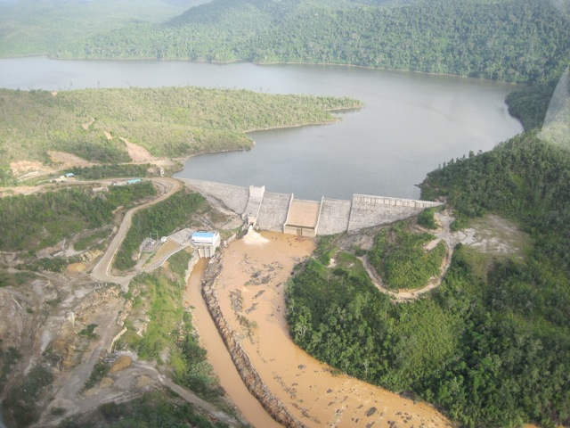
- CITIZEN ENFORCEMENT OF EIA PROVISIONS
Public interest environmental litigation in the Caribbean is rare. There have been only a handful of judicial review cases taken to court from Jamaica, Belize, Trinidad, the British Virgin Islands and the Bahamas in the last ten years. The use of legal mechanisms such as judicial review by environmental public interest groups and NGOs to challenge the decision-making process for developments is still new to organizations and to the courts.
Figure 1: Chalillo Dam in 2007
In 2002, the Belize Alliance of Conservation NGOs an umbrella group of NGOs, applied for judicial review of the decision of the Department of the Environment to approve a proposed dam on the basis of breach of EIA procedures. In 2005, two Jamaican NGOs- the Jamaica Environment Trust and the Northern Jamaica Conservation Association, and four individuals applied for judicial review of the Natural Resources Conservation Authority’s decision to approve a hotel development relying on similar grounds alleging breach of EIA procedures relating to public participation. The cases are known as the Chalillo Dam case and the Pear Tree Bottom case. The facts and decisions are set out below.

The Chalillo Dam case
Belize Electrical Company Limited (Fortis-BECOL), a Canadian-owned company, submitted an application to the Department of the Environment to construct a hydroelectric dam at Chalillo. The project required the flooding of nearly ten square kilometres of land within two forest reserves (the Mountain Pine Ridge Forest Reserve, the Chiquibul Forest Reserve) and a national park (the Chiquibul National Park). The area has the highest density of endangered and rare animal species in Belize, including the jaguar, puma, ocelot species, the Baird’s tapir, the morelot crocodile, and the Scarlet Macaw of which only about 1000 still exist anywhere in the world.The Department of the Environment granted environmental clearance in November 2001 and subsequently the Belize Alliance of Conservation Non-Governmental Organizations filed an action for judicial review challenging the decision.
Figure 2: Chalillo Dam in 2007
The Belize Alliance of Conservation Non-Governmental Organization’s grounds for judicial review included the claim that the National Environmental Appraisal Committee and the Department of the Environment acted improperly by failing to consider the comments and concerns of local communities including those living near the proposed dam and by failing to hold a public hearing prior to a decision being made that would address issues of health and safety. Other issues raised were a failure to address the inadequate hydrological studies, address faulty and misleading geology reports, and to take into account the destruction of large Mayan sites.
In addition, the Belize Alliance of Conservation Non-Governmental Organization’s raised concerns of an implied bias on the part of the Chairman of the National Environmental Appraisal Committee and all governmental representatives on the National Environmental Appraisal Committee based on a public announcement made by the Prime Minister of Belize in support for the project and an agreement wherein the Government of Belize committed itself to construct the access road to the Chalillo dam site and waive on behalf of Belize Electrical Company Limited and its Contractor all licenses, permits, consents and regulatory approvals in connection with the Chalillo project.
The first instance court, though recognizing the inadequacy of the EIA and a failure to precisely follow the letter of the EIA Regulations, ruled that there was inadequate proof of impropriety and/or wrongdoing in the EIA process or on the issues of undue influence. The Court decided there was no doubt that a public hearing was warranted and ruled that the Department of the Environment should hold a public hearing even though in view of the Department of the Environment’s decision “this order would, in effect, sound like putting the cart before the horse.”
The Belize Court of Appeal upheld the decision of the lower court but found that the issues raised were of significance and did merit review by the court of final appeal for Belize, the Privy Council. In 2004, three out of five judges of the Privy Council ruled that although the decision to approve the dam was flawed, it was not illegal. The errors in the EIA were not of such significance to prevent it from satisfying the requirements of the legislation or forming a proper basis for approval by the Department of the Environment. The Privy Council relied on the fact that the EIA regulations stated that the EIA should indicate “gaps in knowledge and uncertainty” and highlight “areas of controversy and issues remaining to be resolved”. It was not necessary for the EIA to be comprehensive or to “pursue investigations to resolve every issue”. They concluded that, “The Government of Belize…has the right to decide to destroy this area if it so chooses...the court challenge was about the adequacy of the EIA. Despite the shortcomings in the information in the EIA, the NEAC accepted the document, which fulfilled the requirements of the EIA Regulations.”
In a strong dissenting opinion, two judges held that they would have quashed the Department of the Environment’s decision to approve the project and would also grant an injunction restraining Belize Electrical Company Limited from continuing work on the project unless and until a corrected EIA is prepared for public consultation, secures recommendation by the National Environmental Appraisal Committee , and approval by the Department of the Environment. Lord Walker of Gestingthorpe concluded at paragraph 121 of the judgement:
Belize has enacted comprehensive legislation for environmental protection and direct foreign investment, if it has serious environmental implications, must comply with that legislation. The rule of law must not be sacrificed to foreign investment, however desirable (indeed, recent history shows that in many parts of the world respect for the rule of law is an incentive, and disrespect for the rule of law can be a severe deterrent, to foreign investment). It is no answer to the erroneous geology in the EIA to say that the dam design would not necessarily have been different. The people of Belize are entitled to be properly informed about any proposals for alterations in the dam design before the project is approved and before work continues with its construction.

  - The Pear Tree Bottom case
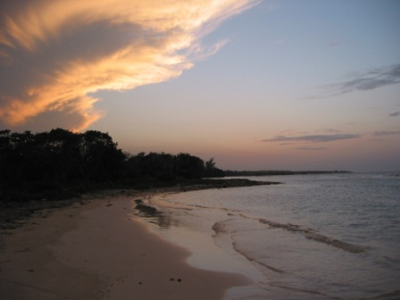
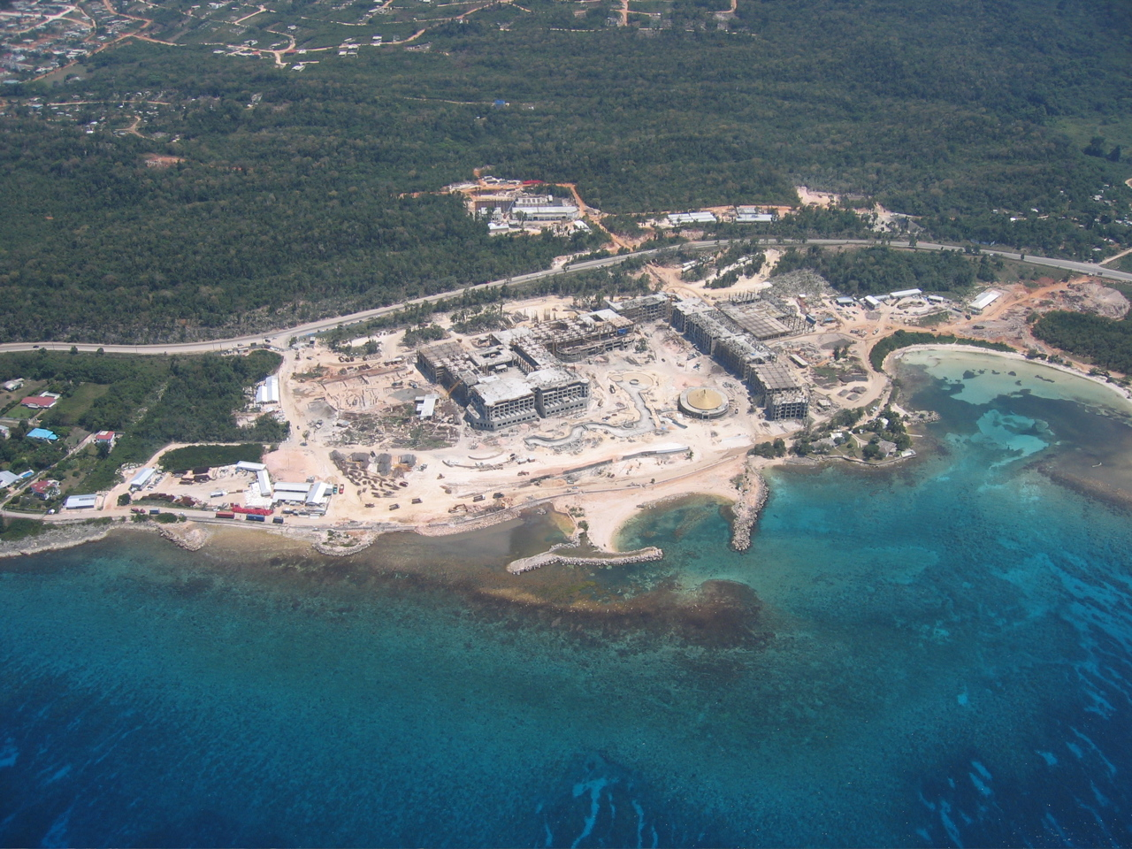
Pear Tree Bottom, located on the north coast of Jamaica, was an ecologically sensitive coastland, slated for designation as a protected area under Jamaica’s Policy for creating a National System of Protected Areas. In July 2005, the Natural Resources Conservation Authority granted a permit to a Spanish hotel development company, Hoteles Jamaica Pinero Limited for the construction of a 1,918-room hotel on the site. Shortly thereafter, NGO’s Jamaica Environment Trust and Northern Jamaica Conservation Association and four local residents applied to the Supreme Court of Jamaica for judicial review of the decision of the Natural Resources Conservation Authority and the National Environment and Planning Agency to grant the permit.
Figure 2: Pear Tree Bottom in 2004 (above) and in 2006 (below)
The main issues addressed by the court were whether the Natural Resources Conservation Authority failed to properly consult with other relevant government departments as provided by statute and whether the public meetings held by the Authority and the National Environment and Planning Agency met the legitimate expectations of the public.
The Court quashed the decision to grant the permit, holding in part, that the agencies failed to meet the legal standard for consultation because they withheld from the public the marine ecology report and two addenda to the EIA. The court also found the agencies abused their decision-making power by knowingly circulating an incomplete EIA, thereby increasing the possibility that the public would make inaccurate and erroneous conclusions about the impact of the development at Pear Tree Bottom. This action deprived the public of information necessary to make a fully informed and intelligent decision and constituted a breach of the public’s legitimate expectation of fair and meaningful participation. The court applied the ‘Sedley definition’ for the legal standard for public consultation which was approved by Lord Woolf in R v North and East Devon Health Authority, Ex Parte Coughlan [2001] Q.B. 213, 258:-
“It is common ground that, whether or not consultation of interested parties and the public is a legal requirement, if it is embarked upon it must be carried out properly. To be proper, consultation must be undertaken at a time when proposals are still at a formative stage; it must include sufficient reasons for particular proposals to allow those consulted to give intelligent consideration and an intelligent response; adequate time must be given for this purpose; and the product of consultation must be conscientiously taken into account when the ultimate decision is taken: R v Brent London Borough Council Ex p. Gunning (1985) 84 LGR 168”
The court cited the Chalillo dam case quoting, in particular, from the dissenting opinion of Lord Walker of Gestingthorpe that “the rule of law must not be sacrificed to foreign investment, however desirable”.
Hoteles Jamaica Pinero Limited intervened after delivery of the judgment asserting undue hardship and improper service of the pleadings. A subsequent court decision varied the initial orders by revoking the order to quash the permit but upholding the declaratory orders that the procedure for consulting the public and governmental agencies were inadequate.

- CONCLUSION
Transparency in environmental decision-making is crucial. Although judges cannot be called upon to determine the merits of a decision, judicial review can be used to scrutinize the decision-making process, ensure accountability and clarify rights. The Chalillo dam and Pear Tree Bottom cases have shown the utility of judicial review actions as a means to safeguard the right to access information about proposed developments and participate in the EIA process. The cases marked the first time in Belize and Jamaica that an NGO was granted standing when it was not directly involved in the area at risk. They also forever changed each country’s perception about the public’s role including the role of NGOs in environmental issues.
The cases also revealed the limitations inherent in the legal frameworks for EIAs in Belize and Jamaica. In both cases, the contested projects were eventually allowed to continue despite flaws in providing access to information and public participation. In the case of Jamaica, while it was outside the scope of the court’s jurisdiction to make any pronouncements on the general right to participate in EIAs in the absence of a statutory requirement, the court imposed the common law standard for proper consultation based on the principles of natural justice and good administration on the regulatory agencies. The application of this standard in practice is limited to instances where firstly, an EIA has been required and secondly, where the public is consulted. In other words, it is only if the Natural Resources Conservation Authority decides to commission an EIA and consult the public that it can be held accountable to this standard. It cannot be said therefore, given the limitations of a discretionary framework, that the judgment has fleshed out general EIA requirements as it relates to public participation.
Despite or because of these shortcomings, the cases provide a welcome evidentiary basis to promote reform aimed at clarifying procedural rights in these countries. Both Belize and Jamaica should include mandatory access to information and public participation procedures within their legislative framework for EIAs. Legislation could lessen the discretion given to public authorities and ensure increased public participation during the process. To accomplish this, Jamaica should enact clear and detailed legislation for the conduct and review of EIAs. In Belize, the EIA Regulations should be reviewed, in particular the wide discretion given to the Department of the Environment to accept flaws within EIAs and to determine if public hearings are required for developments. The law should include a duty to give reasons and responses to public comment. Finally, a more accessible forum at first instance that could hear public complaints about the EIA process needs to be developed to provide greater access to justice without cost barriers.
Building environmental jurisprudence in the Caribbean on procedural rights needs to be continued. However, in the absence of reform, the impression may be left that the long-term value of public interest litigation in the conduct of EIAs in Jamaica and Belize is as a form of protest to delay the grant of approval for developments rather than any meaningful change in the decision-making process for development.

6 REFERENCES

Principle 10 of the 1992 United Nations Conference on Environment and Development (The Rio Declaration). Chapter 8.4(f) and 8.18 of Agenda 21, the Programme of Action for Sustainable Development. Both instruments were adopted by over 178 states at the United Nations Conference on Environment and Development (UNCED) held in Rio de Janerio, Brazil from June 3rd to 14th, 1992. Global agreements which include procedural rights in environmental decision-making include the 2001 Convention on Access to Information, Public Participation in Decision-Making, and Access to Justice in Environmental Matters (the Aarhus Convention), the 1991 Espoo Convention on Environmental Impact Assessment in Transboundary Context and the 1991 Convention on Biological Diversity.
These countries include Barbados, Dominica, Grenada, Jamaica, St. Lucia, Trinidad and Tobago, Bahamas, and Cayman Islands.
Perhaps the exception is research completed by Dr. Winston Anderson. See Anderson, W, Environmental legislative and judicial developments in the English-Speaking Caribbean countries in the context of compliance with Agenda 21 and the Rio Agreements. United Nations Environment Programme and Caribbean Law Institute (2002), available at http://www.pnuma.org/deramb/publicaciones/CaribbeanEnvLaw.pdf and Anderson, W., The Environmental Laws of the Commonwealth Caribbean, Caribbean Law Institute, (1992), p.1. See also, Toppin-Allahar, C., A Comparative Analysis of Environmental Impact Assessment Law and Planning Practice in the Commonwealth Caribbean, The Caribbean Law Review, Vol II No.1 (2001).
See INECE Principles of Environmental Compliance and Enforcement Handbook April 2009, p. 87 available at http://inece.org/principles/PrinciplesHandbook_23sept09.pdf.
The Privy Council of the United Kingdom is the final court of appeal for Jamaica, Belize and a number of other Commonwealth Caribbean islands.
Section 9 of Belize Freedom of Information Act, 1999. Exempt documents under the Act include Cabinet documents, documents containing confidential information and documents where disclosure would prejudice national security, defence or international relations. See Part IV sections 22- 34 of the Act.
Part V of Belize Freedom of Information Act.
Section 18 (a) and (b) of the Environmental Impact Assessment Regulations.
Section 18(c) and 19(n) of the Environmental Impact Assessment Regulations.
Section 18 (4) of the Environmental Impact Assessment Regulations.
Shelton, D, ‘Environmental Rights’ in P. Alston (ed.), People’s Rights (OUP: Oxford, 2001) 185.
Section 24 of the Environmental Impact Assessment Regulations.
Pers. Comm, Candy Gonzalez, Belize Institute of Environmental Law and Policy, April 14, 2011.
Bonine, J. E., Broadening Standing to Sue For Citizen Enforcement, 1999 available at http://www.inece.org/5thvol2/bonine.pdf .
No costs were awarded against a Belizean NGO in its judicial review claim in Belize Alliance of Conservation Non-Governmental Organisations v. Department of the Environment & Anor (Belize) 2004 [UKPC] 6.
Section 7 of The Access to Information Act, Jamaica.
Natural Resources (Prescribed Areas) (Prohibition of Categories of Enterprise, Construction and Development) (Amendment) Order, 2003.
Section 10 (1) (b)of the Natural Resources Conservation Authority Act.
National Environmental Planning Agency Guidelines for Conducting Environmental Impact Assessments (2007), available at http://www.nepa.gov.jm/publications/guidelines/index.asp.
www.nepa.gov.jm.
EIAs for large controversial projects are sometimes listed on the NRCA website.
Section 9(5) (a) of the Natural Resources Conservation Authority Act.
National Environmental Planning Agency Guidelines for Conducting Environmental Impact Assessments (2007), p. 29.
NEPA Guidelines for Conducting Public Presentations, p. 45.
NEPA Guidelines for Conducting Public Presentations, p. 48.
The Jetter, Vol. 1 No. 1. p. 6, available at http://www.jamentrust.org/en/images/stories/pdf_files/publications/the_jetter/The_Jetter_Magazine_2010.pdf.
Legislation to amend Jamaica’s constitution to provide for a Charter of Rights has been drafted. Section 13(3)(l) of the proposed Charter will include “the right, compatible with sustainable development, to enjoy a healthy and productive environment free from the threat of injury or damage from environmental abuse and degradation of the ecological heritage”. The Charter will provide that any person authorized by law, or with the leave of the court, a public or civil organization to make an application to the Supreme Court on behalf of aggrieved persons for a declaration that any legislation or executive act, breaches the provisions of the Charter.
Rule 56.2 of the Civil Procedure Rules of Jamaica, 2002.
Rule 56.15(5)of the Civil Procedure Rules of Jamaica, 2002.
In a judicial review claim filed in 2010 by an NGO and residents against several government agencies relating to a mal-functioning sewage treatment plant, partial costs in the sum of JMD$60,000 (USD 700) were awarded against the claimants for wrongfully joining one of the government agencies in the claim. The Jamaica Environment Trust et al v National Water Commission et al, Claim no. HCV 00114 of 2010.
As environmental activism has increased worldwide in the last few decades, there have been increased opportunities for civil society in the Caribbean to develop the capacity to conduct public interest litigation through the support of private foundations from overseas.
Belize Alliance of Conservation Non-Governmental Organisations v. Department of the Environment & Anor (Belize) [2003] UKPC 63 and 2004 [UKPC] 6.
Belize Alliance of Conservation Non-Governmental Organisations v. Department of the Environment & Anor (Belize) 2004 [UKPC] 6 paragraph 6.
BACONGO v Department of Environment, Decision dated 19 December 2002 at 80.
The Northern Jamaica Conservation Association and Others v. The Natural Resources Conservation Authority and Another (2006) Claim no. HCV 3022 of 2005. 7 BIBLIOGAPHY (these should not be numbered and there should be a space between each one and justified all of the way to left margin) - Anderson, W. Environmental Law Enforcement: The Role of the Judiciary, available at http://www.inece.org/conf/proceedings2/58%20-%20Enviro%20Lw%20Enforcement.pdf - Anderson, W. Environmental legislative and judicial developments in the English-Speaking Caribbean countries in the context of compliance with Agenda 21 and the Rio Agreements United Nations Environment Programme 2002 and Caribbean Law Institute, available at http://www.pnuma.org/deramb/publicaciones/CaribbeanEnvLaw.pdf - Anderson, W. The Environmental Laws of the Commonwealth Caribbean, CLI, (1992), p.1. - Toppin-Allahar, C. “ A Comparative Analysis of Environmental Impact Assessment Law and Planning Practice in the Commonwealth Caribbean” The Caribbean Law Review Vol II No.1 (2001) - INECE Principles of Environmental Compliance and Enforcement Handbook, April 2009. Available at http://inece.org/principles/PrinciplesHandbook_23sept09.pdf - Broadening Standing to Sue For Citizen Enforcement, Bonine, J. E.1999. Available at http://www.inece.org/5thvol2/bonine.pdf - Shelton, D. ‘Environmental Rights’ in P. Alston (ed.), People’s Rights (OUP: Oxford, 2001) 185.

