FINDINGS
STRENGTHENING THE RIGHT TO INFORMATION FOR PEOPLE AND THE ENVIRONMENT PROJECT (STRIPE)

This document summaries The Access Initiative‘s findings from the STRIPE project. These findings will be used to create a publication by the World Resources Institute (WRI) to be released later this year.

EXECUTIVE SUMMARY
Villagers who live in Wat Nong Fab in Rayong Province, Thailand near the Map Ta Phut Industrial Estate are worried the pollution in the surrounding air and water is affecting their health. The industrial estate includes over 140 petrochemical and other industries that discharge pollutants into the air and water. Many villagers have been living near or within the estate for many years and some use the water from well and streams for cooking and in home gardens. They believe the level of pollution is high but do not know what can be done to clean it up.
Community leaders who live near the Tanjung Jati B coal-fired power plant in Central Java Indonesia are concerned about air pollution from the plant. Piles of coal fly ash surround the facility and the ash is often blown into the air. Local leaders are worried that pollution from the plant is affecting villagers’ health and little is being done to reduce it. Some families have moved away because their children have developed respiratory problems and lung inflammation.
Pollution can have long-term impacts on people’s health, even leading to sickness or death. How can community members obtain the information necessary to understand the state of the environment where they live and protect themselves? These stories illustrate some of the difficulties individuals face when they do not have access to information about the air and water around them.
The right to information was established as a universal human right under the Universal Declaration of Human Rights. The 1992 Rio Declaration on Environment and Development recognizes the right of access to environmental information. It states:

At the national level each individual shall have appropriate access to information concerning the environment that is held by public authorities including information on hazardous materials and activities in their communities and the opportunity to participate in decision-making processes. States shall facilitate and encourage public awareness and participation by making information widely available.

People have a right to access information about the air they breathe and water they use in their daily lives. Transparency and access to information enable people to make individual and family decisions that protect their health and support the development of a clean and healthy environment. Preferably, environmental information should be proactively released (released without a request) and made widely available by government. Governments can do this by:

- Collecting comprehensive timely and accurate information
- Analysing data and transforming it into forms that can be understood by and targeted to specific audiences
- Widely disseminating and proactively publishing useable data.

These prerequisites, however, have not been achieved even in countries with laws that provide a right of access to information. This report details the findings of the World Resources Institute’s STRIPE project: Strengthening the Right to Information for People and the Environment with its partners, the Thailand Environment Institute (TEI) and the Indonesian Center for Environmental Law (ICEL), as part of WRI’s The Access Initiative (TAI). TAI is the world’s largest network of civil society organizations working to promote access to environmental information, public participation, and access to justice. The project was conducted from January 2011 to December 2012.
The STRIPE project assessed the:
- Availability of proactively released information on air and water
- Use of the freedom of information (FOI) laws in Indonesia and Thailand to obtain access to discrete types of environmental and pollution control information
- Challenges faced by communities and activists in heavily polluted areas to obtain information on air and water quality.

Clean water and air are common national and global priorities for action. However, the ability to monitor pollution-control efforts or improvements in air and water quality is difficult unless governments collect and release information on the amount of pollution being discharged into the environment. No international instruments exist to require governments to publish minimum classes or types of information about pollution released to the air and water. More needs to be done globally to facilitate the release of information about the discharge of pollutants into the environment and how they affect air and water quality.
STRIPE is the first study in Indonesia and Thailand on the proactive and reactive (request driven) release of information by governments on air and water pollution. The project documented the proactive release of a defined set of information on air and water quality from government agencies as well as the ability of communities in heavily polluted areas to use FOI laws to request access to information on air and water pollution.
In Indonesia, 175 FOI requests were made by community groups, students, and civil society organizations to 34 public authorities; in Thailand, 96 FOI requests were submitted to 8 public authorities.
Requests were made for government-held records on:
- Air and water quality data and standards
- Monitoring of pollutants in the environment
- Pollution reduction planning
- Permitting
- Enforcement and compliance
In addition, specific requests were made for information on the discharges to the environment of two industrial facilities in Indonesia and four facilities in Thailand. The facilities in Indonesia were the PT. Indah Kiat Pulp & Paper (PT. IKPP) Mill in Serang district and the Tajung Jati B coal-fired power plant. See Box 1.
§
Box 1 Indonesia
In cooperation with other civil society and legal aid organizations,ª the Indonesian Center for Environmental Law focused its FOI request efforts on two industrial facilities: the PT. Indah Kiat Pulp & Paper Mill and the Tanjung Jati B coal-fired power plant
The PT. Indah Kiat Pulp & Paper Mill
The PT. Indah Kiat Pulp & Paper (IKPP) Mill located in Serang, Banten Province, produces linerboard, coated boxboard, and corrugated cases. PT. IKPP Corporation is a subsidiary of conglomerate Asian Pulp and Paper. Industrial activity from many industries impacts the surrounding villages with 6,500 people living in the adjacent villages of Kragilan, Cijeruk, Sentul and Luwung. Mill pollution is released into the Ciujung River, which villagers use for rice field irrigation, fish ponds, and daily activities such bathing and washing. There are documented cases of the villagers complaining about river pollution from the mill. The water quality of the Ciujung River, as well as the pollutants released, and regulation of the mill was investigated.
Tanjung Jati B Coal-Fired Power Plant
FOI requests were submitted in regards to the surrounding air quality, regulatory control and air pollutants released from the Tanjanti B coal-fired power plant. Located in Tubanan, Jepara, Central Java Province, this plant is owned by PT. Central Java Power, part of Sumitomo Corporation group. It is located at the edge of Muria peninsula on Java Island and surrounded by numerous small farming villages, including Dukuh Sekuping, with about 85 families and Dukuh Ngelo with 39 families who are impacted by the plant. Villagers have complained about respiratory problems, fly ash, and the odor. In 2008, the 85 families in Dukuh Sekuping (100Ha), Tubanan village, Kembangan, Jepara living close to Tanjung Jati B complained about their health problems to their member of the Central Java local parliament.
Note:
These organizations include WALHI (Wahana Lingkungan Hidup Indonesia, or The Indonesian Forum for Environment), FKPN (Forum Kebangkitan Petani dan Nelayan or Revival of Farmers and Fishermen Forum), Semarang Legal Aid Foundation (LBH Semarang), FORNEL (dan Forum Nelayan Jepara or the Fisherman Forum of Jepara).
In Thailand, the facilities were the BLCP coal-fired power plant; Siam Steel Company Ltd.; Siam Yamato Steel Company, Ltd., and the Phenol Company Ltd. See Box 2.
Box 2 Thailand
The Thailand Environment Institute together with the Eastern People’s Network, worked with community members in the villages of Nong Fab and Mab Kha-Mab Nai concerned about the air and water pollution from four specific industries in the Map Ta Phut Industrial Estate. These facilities included the
- BLCP coal-fired power plant
- Siam Steel Company Ltd.
- Siam Yamato Steel Company, Ltd.
- Phenol Company Ltd.

Established in 1988, the Map Ta Phut Industrial Estate houses 147 factories, including petrochemical plants, oil refineries, coal-fired power stations, and iron and steel facilities as well as an industrial port. The estate occupies 8,000 acres in the Mueang Rayong District, Rayong Province. It was built around approximately 30 agricultural and residential communities with more than 49,000 residents. Ma Ta Phut is one of the Thailand’s most toxic hot spots with a well-documented history of air and water pollution, illegal hazardous waste dumping, and pollution-related health impacts.

STRIPE’S RESEARCH APPROACH

The STRIPE project sought to understand whether increasing access to information by community members and civil society could result in improved action and impetus to clean up and prevent pollution. STRIPE Partners ICEL and TEI prepared reports on the proactive release of information by their governments and the results of the FOI requests. ICEL and the TEI also conducted a systematic review of their countries’ legal mechanisms and policies regarding freedom of information and pollution control to identify and verify:

- What specific air and water quality information is required to be available proactively and released publicly with regard to environmental conditions and pollution control; and
- The quality and categories of air and water information released under their countries’ FOI law in response to information requests.

WRI developed a list of indicators for air and water quality information to be used for analysis. Indicators were designed to assess the:
- Comprehensiveness of the pollution-control and monitoring parameters for general environmental conditions and facility-level information; and
- Availability of the information to villagers about the quality of the Cujung River in Potang, Serang district; the air quality in Tanjung Jati village of the subdistrict Kembangan (Indonesia) and air and water quality in the Map ta Phut Industrial Estate, Rayong province (Thailand).
Each partner undertook analysis in several stages:
- Identification of specific air and water quality information required by law to be publicly available. Project partners inventoried relevant laws and regulations regarding access to information and the government’s obligations to collect and release this information publicly.

- Identification of desired information. Partners selected specific case studies for analysis choosing communities with a long history of concern about pollution in their area. Working with other civil society and legal aid groups, partners held a series of trainings with community members regarding their country’s FOI legislation and environmental requirements. They identified concerns about air and water pollution in the communities and the information they would like to obtain.

- Development of requests for information not proactively available. Based on the indicators and community concerns, partners identified which information was made available proactively by the government. Where information was not available, they developed FOI requests and identifying the most appropriate government authority for submission.

- Submission of information requests. Information requests were submitted to multiple government agencies. In some cases, the requests included multiple questions about individual facilities submitted as a single request.

- Tracking and recording the initial response. Government responses to the information request were tracked and recorded. Follow-up calls were made to ensure that the requests were received and processed.

- Appeals Submitted. If an information request was denied or received a mute refusal (no response within the time frame allowed by law), appeals were submitted and recorded. A template was used to track the FOI requests, including the timeframes, responses from government, and appeals made by partners.

- Analysis of Results. Partners provided an overview and analysis of their country’s legal framework on the right to information including an analysis of the air and water pollution control laws and regulations. They also analyzed the quality of the information received through the information request process and provided recommendations for improving legislative and implementation gaps.

WRI then created a master database and coded all the requests for information. We conducted an analysis of the:
- Proactive release of information in both countries
- Overall response rates to requests: approval, refusals, and mute refusals (failure to respond to requests)
- Response rate by state enterprises and other public agencies
- Form of information granted (written vs. oral)
- Type of information granted (air and water information as well as enforcement and monitoring information)
- Response rate for information on discharges to air and water by private sector companies held by government
- Response rate for FOI request appeals and the Indonesian internal review process.
LEGAL PROVISIONS FOR INFORMATION DISCLOSURE
Indonesia
It is well established that citizens and legal organizations in Indonesia have a right to information held by government bodies under Indonesia’s Freedom of Information law, the Public Information Disclosure Act 2008. The law includes the general principles of freedom of information, specifically (1) public information is open and accessible; (2) exceptions to granting access to public information are restricted and limited; and (3) every requester must be able to obtain information in a timely manner, with low costs and simple procedures.
Each government agency must appoint an information and documentation officer responsible for processing information requests and appeals. When a request is submitted, a public authority must decide whether it has the information and if not, transfer the request to the public authority that does. The law requires that the agency make a decision to grant or refuse a request and provides for partial release of information that is not covered by an exemption under the law (that is, information deemed confidential for a reason set out in the act). The public authority is required to notify the requester in writing if it requires more than the statutory time to respond to the request and can take an additional seven days. Public authorities must also provide a reason for a refusal. If a requestor is denied access to the information requested, he or she may follow an internal appeals process that requires the public authority to reconsider the request. The process is implemented at the government authority where the request was originally submitted. If a requester is not satisfied with the results, the matter can be presented to the Information Commission for Dispute Settlement.
Indonesia’s 2009 Environmental Protection and Management Act (EPMA) states that “persons shall be entitled to environmental education, access to information, access to participation, and access to justice in the fulfillment of the right to a proper and healthy environment.” Indonesia’s EPMA recognizes that environmental information may be in the form of data, information or other information related to environmental protection and management, which is opened for the public according to the characteristic and objectives thereof, such as environmental impact analysis documents, reports and documents of results of evaluation of environmental monitoring, either the monitoring of compliance or monitoring of change in the quality of environment and spatial plans.

Indonesia also has a specific voluntary public disclosure program called the Public Disclosure of Industrial Pollution (PROPER). PROPER releases information to the public in an annual report. It encourages private companies to self-report their environmental performance and compliance with environmental standards. A color rating system is used to grade factories’ environmental performance (gold and green (beyond compliance), blue (compliant), red (not appropriate environmental compliance for some aspects of operation), and black (breach of standards).
The EPMA and a recent regulation passed by the Ministry of Environment require the proactive release of government environmental impact assessments (EIAs), which contain information about the standards to be met by private companies and monitoring requirements. EIAs are conducted to evaluate the impact of a new industry when an initial development or new factory is approved. The EPMA provides sanctions of a one-year detention and a penalty of Rp1 billion (US$103,000) for anyone who provides false information, wrong information, or destroys or obliterates information with regard to environmental protection.
Thailand
Thailand’s 2007 Constitution includes a right to public information, stating that “(a) person shall have the right to know and have access to public data or information in possession of a Government agency, a State agency, a State enterprise or a local government organization, unless the disclosure of such data or information affects the security of the State, public safety or interests of other persons which shall be protected, or unless it is personal information, as provided by law.”
In addition, Thailand’s Freedom of Information law, the Official Information Act of 1997, provides a right of access to information to citizens and residents. Thailand’s FOI law gives persons the right to obtain a copy of information or inspect information from government authorities. It does not include specific time periods for responses requiring only that information be provided within a reasonable time. If a public authority intends to refuse information, it must give the public “a reasonable time” to lodge an objection. Under the country’s Governmental Good Governance Law of 2003 “reasonable time” is interpreted as 15 days.
Thailand’s FOI law also guarantees the public’s right to obtain access to official information in the possession of state agencies including: (1) examining information; (2) the right to seek any other official information; and (3) the right to request a copy or certified copy of an official document. The official information provided by the government agency must be “ready to be made available without requiring new preparation, analysis, classification, compilation or creation.” However information may be created to respond to a request if it is consistent with an organization’s powers and duties. The law gives no right of internal review of decisions to refuse a request. The process of FOI enforcement in Thailand involves submitting an appeal to the Information Disclosure Tribunal and then receiving a notice of action by the Tribunal to the responsible agency. This notification is followed by the requestor being asked to inform the Information Disclosure Tribunal what difficulty was faced in obtaining the requested information.
This FOI law was amended in 2010 to list 16 categories of information that must be proactively released by every government agency that holds it. For example, it provides for the proactive release of data, reports, and analysis concerning monitoring of operations, impacts of pollution including dangerous risks from industrial processes, contaminants in various environmental settings, and measures to prevent and solve environmental and health problems.
Information is also required to be proactively released online in an annual State of Pollution Report by the 1992 Enhancement and Conservation of National Environmental Quality Act.

LIMITED PROACTIVE AIR AND WATER QUALITY INFORMATION AVAILABLE
Despite wide mandates in law to provide information proactively in Indonesia, only a limited amount of information regarding air and water quality relevant to the project was available. In Indonesia, this information should have been provided through the PROPER system. However, PROPER does not include: (1) the release of background data on the process or reasoning behind a facility’s rating; or (2) information on the kinds of chemicals and hazardous substances released into the environment.
The EIA information provided was highly technical and did not contain information on current releases to the environment by industry. PROPER and EIA information were not available locally in the communities during the STRIPE project. In addition, enforcement and compliance information about whether companies met air or water discharge standards was not proactively released by government.
In Thailand, information was generally not available as required under article 9(8) of the FOI law. However, information was available proactively in other forms relevant to the project. Air quality information for specific pollutants was provided on electronic monitoring equipment signs onsite in the Map Ta Phut Estate.
Thailand’s State of Pollution Report 2011 report included information on common air pollutants and on surface and groundwater contaminants. The locations of Thailand’s specific air and water monitoring sites were released along with detailed charts listing the specific chemicals, regulatory parameters, and quantities measured in the environment. Air and water quality measurements taken in the Map ta Phut community were provided.
General information regarding the potential health impacts commonly associated with specific chemicals, including those released in Map Ta Phut, was also given for some pollutants. The specific sources of the pollutants were mentioned only in general terms such as “emissions from vehicles, factories, construction sites, and open burning.” Information about releases from individual facilities was not included. Although acknowledging that pollution was impacting public health in broad terms, the report limited discussion of specific health impacts to statistics about spills, accidents, or poisonings. No long-term potential health impact from ongoing pollution was examined even in areas where violations of standards were recorded. Overall, the report was technical and broad in scope. Little information was available about sources of the pollution, mitigation of pollution, cleanup, or enforcement.
Our project partners’ review found that much of the information communities wanted was not available without the submission of an information request. Information on the ambient air quality and water quality for some specific pollutants was available in Thailand for the industrial estate. This was not the case in Indonesia for air or water quality. Information on the quantity of pollutants and combined pollutants and their impact on the environment and health were largely unavailable in both countries. Permitting and enforcement information was not proactively made available. In both countries, some laws and standards regarding the release of pollutants were available on the internet. Legal text and standards were publicly available on water pollution standards for point sources, as were drinking water standards at point-of-use and source (that is, reservoir, tap, or spring). Air quality standards were also available for ambient air and large stationary sources. Community members in heavily polluted areas in Indonesia and Thailand could not use publicly available information to gain a meaningful understanding of the quality and condition of the air they breathed or the water they used.

RESPONSES TO FREEDOM OF INFORMATION REQUESTS WERE LIMITED
FOI laws offer the potential to ensure timely access to environmental information for citizens from their governments because they allow citizens to make a request for specific information and provide for enforcement of this right. Many FOI requests submitted in Indonesia specifically asked about pollution control and discharges from the PT. IKPP paper mill and Tanjung Jati B coal-fired power plant. In Thailand, FOI requests included more general inquires about the names and types of specific factories in industrial estate facilities and general policy on pollution discharges. In addition, requests were made about four specific industrial factories located in the Map Ta Phut Industrial Estate. Information requests submitted in both Indonesia and Thailand included questions about environmental impact assessments, inspection reports, air and water quality monitoring documents, and copies of permits for specific air and water discharges.

FOI requests by community members focused on concerns over health and the risk of using contaminated water. Indonesian community members submitted questions about proposed plans to expand the Tanjung Jati B power plant as well as the regulation of the ash waste generated and the coal shipping traffic. Preventing fish from being caught in the power plant’s uptake valve was also a concern. Communities surrounding the PT. IKPP paper mill submitted requests asking for the complete list of industries discharging into the nearby river as well as the overall river water quality. They were also concerned about the potential of illness from consuming river water or contaminated well water. In Thailand, most of the requests made by community members pertained to the usability and safety of the water sources, including rainwater, water wells, and river water. Community members were especially concerned about using this water for drinking and for other everyday uses, such as bathing and gardening. Some requestors also asked about steps they could take to reduce any potential contamination of this water.

Limited Relevant Information Available through Information Requests
Response rates to FOI requests varied significantly between Indonesia and Thailand. Indonesian government authorities refused or gave a mute refusal to the majority of requests submitted: information was granted for only 34 percent of the cases (59 requests). Thailand government authorities granted almost 68 percent of submitted information requests. However, many requestors in Thailand indicated that they were not satisfied with the information received. Sixteen percent of the Thai Government responses were incomplete and did not permit community members to obtain a fair understanding of their concerns.

Many Mute Refusals and Delayed Answers
Mute refusals were a significant problem in both countries, especially in Indonesia. Over 60 percent (106 of 173 cases) of Indonesian information requests were met with a mute refusal. Although the majority of Thai requests were granted, 24 percent (23 of 96 cases) received a mute refusal. Both Indonesian and Thai government authorities took a varied range of time to answer information requests. Indonesian government authorities took 4 to 27 days to send a decision. Thailand government authorities averaged over 51 days to answer a request.

The number of requests granted, refused, or given mute refusals is shown in Figure 1.

Figure 1 Government Response Rate to FOI Requests in Indonesia and Thailand

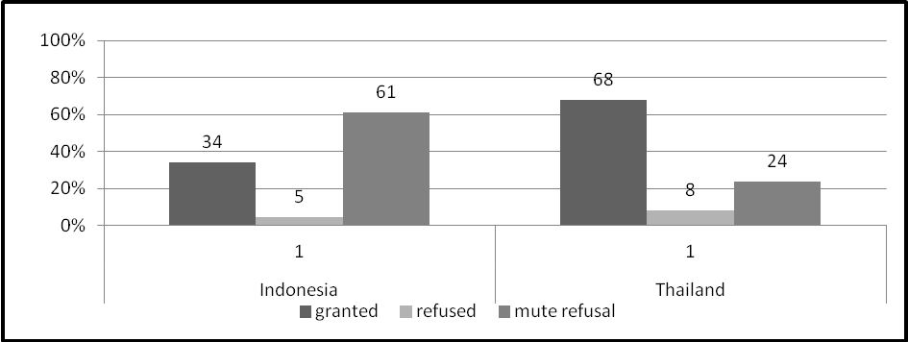

Forms of Information Provided
Indonesian requesters usually received written information in response to requests. However, in Thailand, almost half (49 percent) of requesters received no written information but rather were given oral responses or asked to obtain the information at the government agency. Thai government authorities did not provide official reasons in writing for most of their refusals to provide information. Reasons are needed by the public in order to assist them in making an appeal under the FOI law. See Figure 2.

Figure 2 Form of Delivery of Government Responses in Thailand

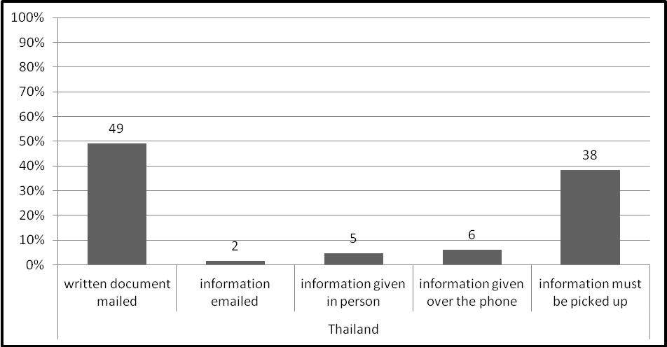

Limited Monitoring and Enforcement Information Provided
Indonesian government authorities responded with a mute refusal for over 71 percent of the requests for environmental monitoring information. Indonesian government authorities gave a mute refusal or denied over 54 percent of the requests regarding information on whether enforcement action was taken. Almost one third of the Thai monitoring information requests were denied or there was a mute refusal.
Overall, Requests about Air or Water Were Treated Similarly
Responses varied in the treatment of requests for information depending on the public authority to which the request was submitted. There was equal likelihood of requests being granted or denied whether the request was made for air or water information.
Local Governments, Public Authority, and State Agencies Had Varying Response Rates
Indonesian and Thai requesters submitted information requests to national government ministries, local government agencies, and state-owned enterprises. In general, national ministries granted more information than state-owned enterprises. Indonesian state-owned enterprises (Tanjung Jati B power plant, or state electricity companies) provided a mute refusal response for 87 percent of the requests submitted. Although Thailand’s state-owned enterprises granted the majority of the requests submitted, they denied or provided a mute refusal for over 41 percent of requests. This percentage represents a much higher rate of mute refusals than other Thailand national government authorities. Figure 3 shows detailed data on the status of requests.

Figure 3 Public Authorities’ Responses to FOI Requests, Indonesia and Thailand
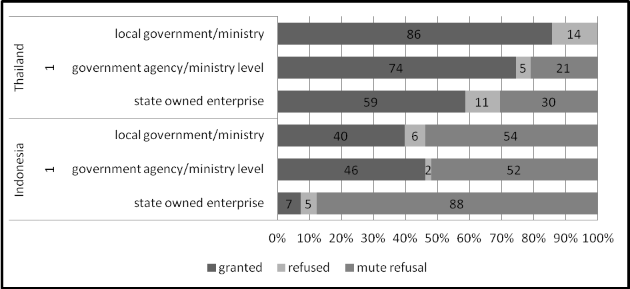

Requests about Polluting Facilities
In Indonesia, most of the requests submitted about the two industrial facilities were either denied or resulted in a mute refusal. In Thailand, most requests for information about facilities, in general, and the four factories in particular were granted, although only a small number of requests were submitted about each facility. The response rate for all facility specific questions is provided in Figure 4.
Figure 4 Responses to Facility-Specific Requests
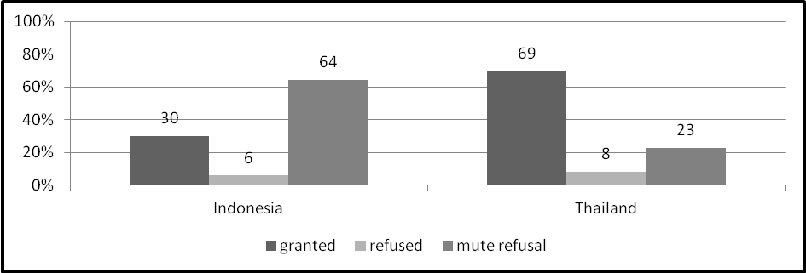

Facility Information Highlights Regulatory Gaps
The information received from specific facility requests was valuable to civil society and communities in Indonesia because it:
- Highlighted gaps in the types of pollutants regulated including many toxic pollutants such as mercury and volatile organic compounds released into the air by the coal-fired power plant. It also revealed that in the case of the pulp and paper industry, the existing legal standards did not cover specific chemical standards for chlorinated organic compounds.
- Revealed that there was no monitoring of the communities health in areas near the coal power plant even though health concerns were raised when the plant was being built.
- Enabled community members to find out about a renewal of the pulp and paper mill’s license without a public participation period as required by law.
- Established the fact that there was only intermittent monitoring of the quality of the water in the river to which discharges were being made by the pulp and paper mill.
- Established breaches of standards by facilities and revealed lack of enforcement.
In Thailand, most information requests yielded only limited information needed to determine the severity or risk of pollution discharges. Most of the information received contained technical air and water quality monitoring data. Information about water quality was either incomplete or given only as average annual estimates. Although some specific pollutant levels were released, very limited information was made available on violation of standards or on government enforcement actions.
Barriers for Communities

Difficulties using FOI laws. Community members in both countries indicated difficulties in tracking and following up on responses to requests as well as using the internal review (Indonesia only) and appeal procedures.

Disappointing response rate to requests. Community members in Indonesia had their information requests denied either through mute refusals or express refusals 76 percent of the time. While the majority of information requests submitted by community members in Thailand were granted, 40 percent of their requests were refused or had a mute refusal response.

Difficulties understanding information. Community members in both countries documented difficulties in obtaining easily understandable information. In both Indonesia and Thailand, communities were sent technical information that was very difficult to understand. In Thailand, information was often provided verbally, which made it difficult for citizens to share it with other community members, interpret it, or take action. In some cases, the answers were given in English instead of Thai or Indonesian. In both countries, intermediaries were needed to explain the information

Location and cost obstacles to information. Costs played a role in obtaining information. In Indonesia the FOI law permits public bodies to charge for duplication and delivery of information. These charges made obtaining information prohibitively expensive for ordinary community members. For example, a large volume of EIA documents were available only in hard copy at cost. In Thailand, community members were charged for photocopying and official verification of photocopied pages. In both countries, a significant amount of relevant information was only available in Bangkok and Jakarta. This became a limiting factor in more than one case because community members could not afford the travel costs.

Providing reasons for making a request. The Indonesian FOI law requires a reason for making a request; thus, in several cases, citizens were asked why they needed the information. In Thailand, officials asked for a reason for requests even though the law does not require it. In a few cases, officials called or visited requestor’s homes. Many requestors believed this was to discourage them from pursuing further official requests. In both countries, some community members felt uncomfortable contacting officials and they were often not comfortable writing requests or appeals. In some cases in Indonesia, community members reported they were afraid to file information requests about specific facilities because of possible intimidation if the company was told who made the request for information.

Appeals
In both countries, despite having independent review mechanisms (Office of Information Commissioners/ Information Disclosure Tribunal) requestors catalogued difficulties in the appeal process.
In Indonesia, over 80 percent of the appeals made by requestors were denied, including 96 percent of the appeals submitted by community members. These appeals included 68 cases where the original FOI request was met with a mute refusal and two cases that were initially denied. Most petitions submitted for internal review, 42 cases in total, were also denied; including all appeals regarding state-owned enterprises.
In many cases, Thailand requestors, who were dissatisfied with the information provided, did not take additional action. Where appeals were pursued, less than half were granted by Thailand’s tribunal, including 14 cases in which the original FOI request was met with a mute refusal and six cases that were originally denied.

DEFICIENCIES IN FOI LAWS AND IMPLEMENTATION
Requesters in both countries found it difficult to identify officers responsible for accepting FOI requests or answering queries about requests. No FOI requests were refused in either country based on exemptions contained in the law. FOI requests were most often responded to with a mute refusal. Where information was refused in writing, there was usually no specific exemption in the law cited to justify the refusal. Although the number of mute refusals was higher in Indonesia than in Thailand, the problem of failure to receive a reason for a refusal severely hampered requesters’ ability to make appeals.

Specific deficiencies in Indonesia’s public disclosure law include:
- There is no working detailed “transfer” mechanism implemented by public bodies when information requested by the community is held by another public body. For example, there were seven requests for air-related information in which the public bodies neither possessed the requested information nor transferred the request to another public body.
- Requirements to provide a reason for their request hampered community members’ use of the law.
- State-owned agencies claimed that their obligations under the law were limited to providing a discrete set of information and did not respond to requests for pollution, monitoring, and enforcement-related information.
- Appeal mechanisms under the PIDA and Information Commision regulations were long and difficult for community requestors to use and required assistance by civil society organisations, which had to navigate new mediation and enforcement requirements.
Specific deficiencies in Thailand’s Official Information Act include:
- Lack of a specific time period for provision of information. The Official Information Act specifies only that information must be provided in a reasonable time. Although a 15-day period has been defined as “reasonable,” the lack of a time requirement for acknowledgements and final decisions make it difficult to track information requests.
- Persons who could not read or write found it difficult to use the law without a provision to allow oral requests and to receive information in a form that they could understand.
- Lack of regulations to require agencies to designate FOI officers, or adopt internal procedures to answer requests slowed the response process.
- Failure to provide for internal and external enforcement procedures against agencies and officials that do not fulfill the legal requirements to proactively release environmental and health information.

NINE RECOMMENDATIONS
The findings reveal gaps in the proactive release of information to the public as well as deficiencies in FOI laws and their implementation by government agencies. Achieving meaningful proactive transparency of information on air and water quality is critically needed in Indonesia and Thailand. STRIPE sought to ascertain priority actions that could improve access to information on air and water and ultimately enhance the environment and public health. Following a cross-country analysis of findings, STRIPE offers nine concrete recommendations of next steps for action.
1. Improve Proactive Transparency
Environmental information should be released proactively to ensure communities are not affected detrimentally by hazardous pollution, and can make informed decisions about their health and well-being. Information on pollution in air and water bodies used for domestic needs (ambient air and water quality) must be provided in a way that is timely, comprehensive, and in forms that can be understood by the public. Currently, FOI processes lack these necessary elements in both countries.
Public information on the types and quantities of pollutants released into the environment by state and private industry, as well as regulatory and monitoring information, should be provided by the government. This information includes:
- Legal standards for pollution
- Types and quantities of pollutants discharged
- Monitoring data
- Permits to discharge pollution into the environment
- Enforcement and compliance about meeting standards.
Indonesia and Thailand’s FOI laws have broad provisions that could be used to promote more proactive release of environmental information. Administrative provisions could be developed to identify types of environment and health information and the form in which it is to be released. Support for development and implementation of proactive release mechanisms in Indonesia will ensure compliance with the new Environmental Protection and Management Act’s requirements for an integrated environmental information system. Thailand’s 2010 amendment to its FOI law encompasses many of the components required for providing proactive access to minimum classes of information. Procedures should be developed for consistent implementation and enforcement of proactive transparency rules across government agencies.
2. Improve Understandability of Information
Information provided by government authorities is often incomplete or too technical for communities to understand. Information should be provided in easily understandable forms. Methods to accomplish this goal could include simple signs, use of simple reports, community meetings, and mobile phone or radio alerts on the quality of air and water. Community information centers and other culturally appropriate forums could improve access to different types of information.
3. Implement FOI Laws
Implementation of FOI laws needs significant improvement in both countries, including more detailed administrative rules. More environmental information needs to be released through FOI requests. Indonesian and Thailand government authorities need to develop systems to track and respond to requests in a timely fashion, granting or refusing access to information within the terms of the law. Appointing effective information officers to receive, process, and respond to requests should be a priority in both countries.
New mechanisms need to be put in place to reduce the barriers for communities to use FOI laws at the local level. Requiring requesters to travel, copy, and pay for the information clearly places an undue hardship on many community members.
Appropriate budgets and training for government officials must be a priority. Administrative regulations that mandate operational standards need to be harmonized and implemented.
4. Release Information on Company Pollution
The STRIPE findings suggest a need to adopt mechanisms for the mandatory release of company polluting information. Monitoring information for specific private facilities is especially difficult to obtain using the Indonesian and Thailand FOI laws, even though this information is held by government.

Citizens need information about the pollution released from industries in their local communities even when state officials may receive an objection or no consent from the private company. The public interest is paramount. Providing general regulatory information is not enough to ensure pollution prevention or clean up.

5. Monitor Compliance with FOI Laws
Neither the Thai appeal process nor the Indonesian appeal and internal review process resulted in significantly more information becoming available. Greater clarity is needed on the reasoning and decision making of the information commissioners and on why using the enforcement procedures did not result in more environmental and health information being released to communities and civil society.
Independent officials must carry out compliance monitoring and enforcement requirements under the law. Monitoring of compliance with the law by information commissioners and tribunals in both countries should be a priority to reduce the number of mute refusals. Creating simple procedures for appeals, providing information about response rates of government agencies to the public, executive and legislative arms of government as well as outcomes of appeals from specific government authorities may be a positive intervention in both countries.
6. Support Community Capacity to Use FOI to Improve Local Environments
Communities face challenges and barriers when they seek information on air and water quality. Community members need support to utilize FOI laws. Many community members stopped their information request process when their request was initially denied or when they faced a mute refusal. Both government and civil society have a role to play in presenting information in a format more responsive to communities’ needs. Government must provide civic education and information to explain the public’s rights and duties.

Civil society capacity must be built to support community involvement. An active civil society is needed to:
- Support initiatives to translate technical pollution control and policy information into easily understandable forms and to provide the appropriate forums for getting this information out into communities
- Advocate for better opportunities to use the collected information including stronger public participatory requirements in the air and water pollution regulatory process
- Educate community members about their rights to access information and how to get these rights enforced
- Work with community members to use the collected information to protect public health and environment.
7. Release Enforcement and Permit Information
Permit and enforcement information needs to be more easily obtainable to ensure that regulatory agencies are enforcing the law and pollution standards. Release of permits and enforcement information in open, easily accessible formats can help governments promote compliance with standards. It can also help communities demand greater accountability from industry.
8. Allow Access to State-Owned Enterprise Information
State-owned companies operate under the same pollution-control regulatory environment as private industry. As a result, state-owned enterprises must be required to release information about their achievement of pollution control standards. In addition, State-owned companies must be held accountable to comply with FOI laws with the same standards of implementation and compliance as other government agencies.
9. Reform Freedom of Information Laws
Deficiencies in FOI laws in Indonesia and Thailand adversely affected people’s ability to access information. Although the reform of FOI laws may be a long-term goal, the gaps we identified need to be addressed urgently. Inclusion of specific time periods within the laws for meeting deadlines and providing means to hold officials accountable to the requirements of the law are needed. Specific provisions to address barriers faced by community members should be considered, including allowing oral requests over the phone and waiving copying costs. Simplifying appeal procedures and removing requirements to give reasons for information requests should also be considered where applicable. Many of these reforms could be done through administrative regulations as a short-term solution.

CONCLUSION

The Governments of Indonesia and Thailand have taken progressive steps to improve transparency by the adoption of FOI laws and specific regulatory provisions to improve access to environmental information. However, more needs to be done to make relevant information available to ordinary citizens. Communities that are aware of and have access to information on the quality of their air and water have the opportunity to demand action by regulators and polluters for pollution prevention and clean up. As the types, the number, and the complexity of pollutants released into the environment continue to increase as a result of industrialization, more will have to be done to provide relevant information proactively to the public. Governments will need to continue to define what pollution information must be collected by public authorities and in what form it will be released to the public. Independent commissioners and tribunals with an enforcement role under FOI laws play a distinct role in this effort and need strengthening.

When used effectively, transparency can support national goals to improve the health of citizens and enhance efforts to prevent pollution and ensure environmental sustainability. Access to information can be a powerful tool to support clean air and water goals.

Article 19 of the Universal Declaration of Human Rights. See www.article19.org/pdfs/publications/foi-as-an-international-right.pdf
Principle 10 of the 1992 Rio Declaration on Environment and Development.
Foti, Joseph , Lalanath de Silva, Heather McGray, Linda Shaffer, Jon Talbot, and Jacob Werksman, 2008, Voice and Choice: Opening the Door To Environmental Democracy, World Resources Institute.
http://siteresources.worldbank.org/ENVIRONMENT/Resources/Env_Stratgy_2012.pdf
Foti et al.
Another study comparable to this one was completed in China on access to environmental information, but it did not focus on water and air. See http://www.article19.org/data/files/pdfs/reports/access-to-environmental-information-in-china-evaluation-of-local-compliance.pdf
WRI conducted its analysis based on the number of specific questions asked rather than on the total number of information requests submitted. Information requests submitted in Indonesia and Thailand often contained multiple questions within one FOI request or, in the case of Thailand, asked for multiple answers for different facilities within a single request.
Some of the information requested was as a result of conditions of an EIA that required private industries to produce and submit information to the government regarding monitoring information of discharges into the environment.
Public Information Disclosure Act (PIDA) of 2008
Article 2 of PIDA.
Article 17 of PIDA.
Article 65(2) of EPMA.
PROPER obtains legal authority through Regulation No. 5 / 2011of the State Minister of Environment.
Regulation No. 6 /2011 of the State Minister of Environment
Article 133 of EPMA.
Article 56 of the Constitution.
Article 26 of Official Information Act of 1997.
Amended in 2010 to add Article 9(8) to the Official Information Act of 1997.
Required by Article 53 (9) of the 1992 Enhancement and Conservation of National Environmental Quality Act .
Information contained in EIA’s included detailed descriptions of the technical processes involved in the industry and the maintenance and management of equipment relevant to the discharges to the environment.
Air pollution information was released on volatile organic chemicals (VOCs), carbon monoxide, sulfur dioxide, ozone, and water pollutants including particulate matter such as fecal coliform, nitrates, and heavy metals
http://www.pcd.go.th/public/Publications/en_print_report.cfm?task=en_report2554
The effects of mercury on health are well documented by the US EPA. http://www.epa.gov/hg/effects.htm
The effects of VOCs on health are well documented by the US EPA. http://www.epa.gov/iaq/voc.html
The effects of chlorinated organic compounds are well documented by the US EPA. http://www.epa.gov/chemfact/f_chlori.txt
In Indonesia, the information commissioner has determined that the absence of a reason should not be grounds for not processing an information request or giving a refusal.

