10 G Street, NE Suite 800 Washington, DC 20002 USA (PH) +1 (202) 729-7600 (FAX) +1 (202) 729-7610 www.WRI.org

Global Forest Watch Water:
Empowering the World for Healthy Watersheds

The World Resource Institute (WRI) is developing a new global mapping platform to empower stewards of watersheds – citizens, governments, and business – around the world to take action to improve watershed health. Joining WRI’s suite of applications of the interactive online forest monitoring system Global Forest Watch (GFW) as GFW Water, this publicly available tool will allow anyone with internet access to visualize critical watershed related information, threats to watershed health, and screen for cost-effective, sustainable solutions.

The Challenge
By 2030, the world is projected to spend an estimated $10 trillion on repairing and expanding water infrastructure. As water demand surges, dams and treatment plants age, and more frequent extreme weather events threaten our water security and drive up water management costs, need is growing for lower-cost approaches to secure ample and clean water. At the same time, efforts to safeguard water resources with innovative “natural infrastructure” approaches – such as forest protection, watershed restoration, and sustainable management of landscapes – are expanding around the world. These solutions are often easier on ecosystems, human communities and bank accounts than traditional energy-intensive, hard infrastructure approaches.
But information on both threats and solutions is often scattered or presented in unfriendly forms. GFW Water seeks to overcome these obstacles building on remarkable advances in satellite remote sensing as well as data aggregation, visualization, and distribution. Using GFW Water, anyone will be able to gain access to information that WRI and our partners stitch together into a meaningful whole.

The Data
GFW Water presents credible, relevant, and timely information to help users improve watershed health in three parts (Figure 1.):

Know Your Watershed: Navigate users to visualize critical watershed related information and locate important water infrastructure:
Layer | Description | Resolution/Scale | Geographic Coverage
Rivers | Major rivers and tributaries | 1:147 million to 1:2.3 million | Global
Wetlands & Lakes | Large lakes and reservoirs, smaller water bodies, and wetlands. | 30 x 30 arc second (approx. 900 meters) | Global
Tree Cover | Areas of tree cover | 30 × 30 meters | Global land (excluding Antarctica and Arctic islands)
Potential Tree Cover | Potential extent of tree cover | 30 arc second  (approx. 900 meters) | Global land (excluding Antarctica and Arctic islands)
Land Cover | Land cover categories | 30 arc second  (approx. 300 meters) | Global land (excluding Antarctica and Arctic islands)
Major Dams | Location and status of dams | Varies by country | 50 major river basins
Water Withdrawal | Water withdrawal locations | Varies by country | Select 250 + cities with a population greater than 750 K

Identify Watershed Risks: Help users understand the type and severity of threats to watershed health:
Layer | Description | Resolution/Scale | Geographic Coverage
Tree Cover Loss | Areas of gross tree cover loss | 30 × 30 meters | Global land (excluding Antarctica and other Arctic islands)
Tree Cover Gain | Areas of tree cover gain | 30 × 30 meters | Global land (excluding Antarctica and other Arctic islands)
Sedimentation | Areas of high sedimentation potential | 15 arc second  (approx. 450 meters) | Global
Active Fire | Fire alert data for the past 7 days | 1 × 1 kilometer | Global
Baseline Water Stress | Measures relative water demand | n/a | Global land (excluding Antarctica and other Arctic islands)

Plan for Action: Provide users with relevant recommendations for natural infrastructure strategies in watershed conservation, restoration, and sustainable management practices according to watershed risk profile. Empower users with applicable guidelines and decision-support frameworks to help facilitate on-the-ground actions to improve watershed health.

Tool Features
GFW Water includes the following features to allow users to make the best of never-before-seen information to lead to real action for improving watershed health around the world:
Global comparability. All data layers and analysis will be applied to watersheds around the world.
Define your own watershed. To obtain more granular information, users can customize e sub-watershed based on hydrological and topographic models from a point of interest for analysis anywhere in the world.
Best available data and near-real-time updates. We strive to present the best and most up-to-date data based on most robust scientific models, WRI’s existing data assets, and extensive networks of experts and partner institutions.
Beyond the numbers. GFW Water brings together powerful decision-supporting roadmaps and resources from WRI’s Natural Infrastructure for Water Project, Global Restoration Initiative, and more to empower users to take on next steps to design, implement, and monitor on-the-ground initiatives to improve watershed health.

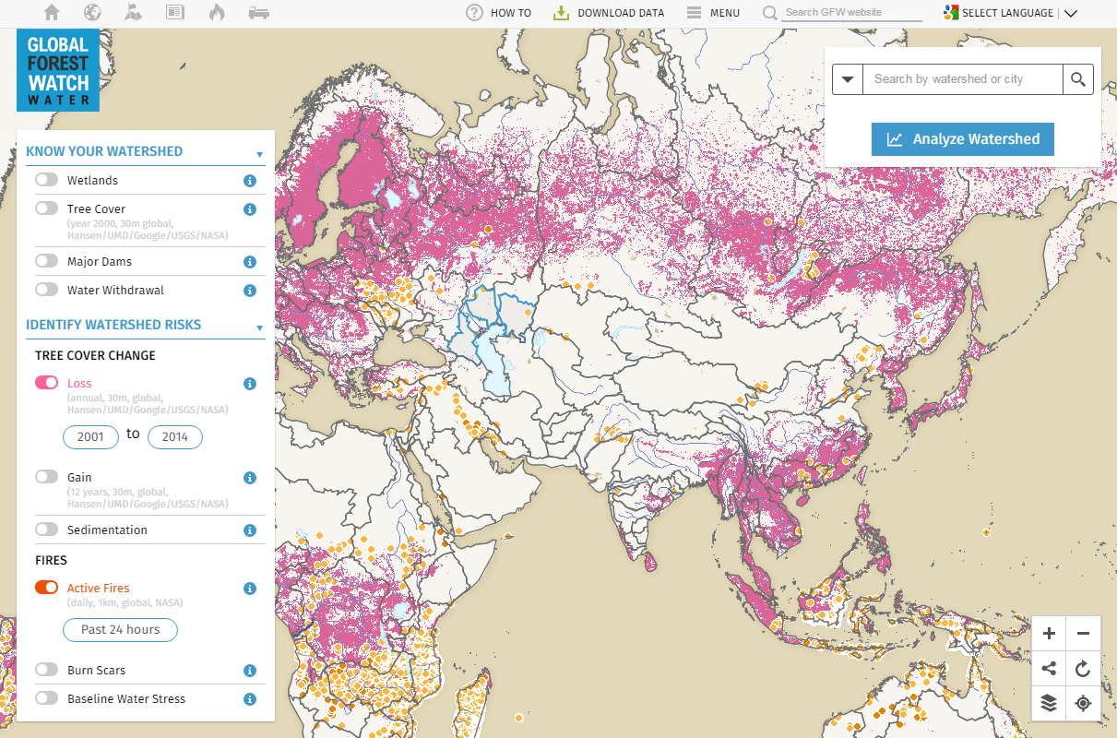
Figure 1. GFW Water (in progress) showing tree cover loss from 2001 to 2014 and active fires in the past 24 hours.

For more information, please contact Yiyuan Jasmine Qin at yqin@wri.org.

