Water Governance
OECD: Water governance is the set of rules, practices, and processes through which decisions for the management of water resources and services are taken and implemented, and decision-makers are held accountable.
Water Governance Facility: The political, social, economic and administrative systems in place that influence water’s use and management. Essentially, who gets what water, when and how, and who has the right to water and related services, and their benefits.

What is Water Governance?
http://watergovernance.org/water-governance/
http://watergovernance.org/resources/users-guide-on-assessing-water-governance/
http://watergovernance.org/resources/indigenous-peoples-and-industry-water-users-mapping-the-conflicts-worldwide/
http://www.oecd.org/gov/regional-policy/OECD-Principles-on-Water-Governance-brochure.pdf
Enabling conditions for water governance - 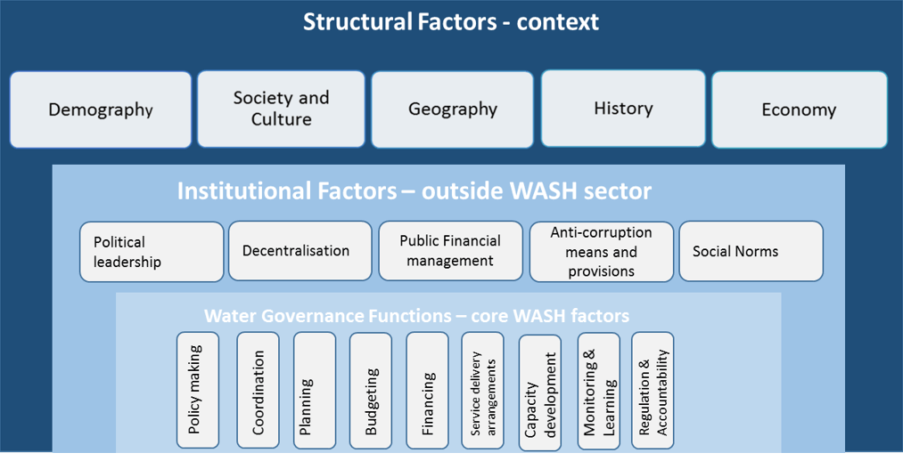
file:///C:/Users/elizabeth.moses/Downloads/WGF-Enabling-Environment-and-Water-Governance_March-20161.pdf

Water Governance and Pollution
Governance matters for mitigating industrial water
pollutionhttp://www.sciencedirect.com/science/article/pii/S0264999314002648
Our findings reveal that the rule of law, regulatory quality, control of corruption, government effectiveness and voice and accountability are negatively and statistically significantly correlated with water pollution across all industrial activities as well as specific industry groups

Create matrix of governance and function (decision making, supervision, execution, coordination)
MOEF etc

http://www.globalwaterforum.org/2012/06/09/water-pollution-in-asia-the-urgent-need-for-prevention-and-monitoring/

http://waterfootprint.org/media/downloads/Hoekstra-2011-Global-Dimension-of-Water-Governance_1.pdf
Goal 6. Ensure availability and sustainable management of water and sanitation for all

6.b Support and strengthen the participation of local communities in improving water and sanitation management

6.b.1 Percentage of local administrative units with established and operational policies and procedures for participation of local communities in water and sanitation management

https://portals.iucn.org/library/efiles/edocs/2009-002.pdf
creating water governance capacity
Linking Policies to Realities
Transforming Policy into Law
Building a Sound Institutional Mechanism
Implementing Water Governance Capacity

profoundly political element to water governance and as such systems of water governance usually reflect the political realities at international,national, provincial and local levels.
The Dublin Statement on Water and Sustainable Development (1992) reflects the origins of such an approach. “Water development and management should be based on a participatory approach, involving users, planners and policy-makers at all levels.” Decisions are taken at the lowest appropriate level, with full public consultation and involvement in the planning and implementation of any activity that affects water.[1]

What is Water Governance?
Water resources management vs water service delivery
How do we define stakeholder engagement in this context?
Ladders and levels
Participation vs engagement
OECDs six necessary conditions to create an enabling environment for inclusive water governance
What this means to STRIPE
What’s your lens?
Who are the institutions?
Relevant policies

To be successful, a public-participation process requires specific institutional arrangements: • Establishing an enabling national framework • Raising awareness of water, environmental and health issues • Identifying a broad group of stakeholders • Setting up a balanced coordination mechanism • Taking into account provisions such as costs, time and human resources

The following are the key principles relating to public participation: Equity and inclusiveness: reaching out to all stakeholders and offering them equal opportunities to participate. Accountability and transparency: employing transparent and democratic mechanisms, publishing results in an understandable and traceable way, and providing recourse mechanisms. Flexibility: keeping the approach flexible by taking into account different issues, participants, value diversity, linkages into decision-making and time frames. Effectiveness and speed: organizing the process so that competences, roles and time frames are clearly and realistically defined. Responsiveness: the process has to follow stakeholder needs and requirements and must take their input into account.

Enabling environment
Institutions
Legal framework
National legislation
Awareness building
Identifying stakeholders and setting up coordination mechanisms
Cost, time and human resources

Setting targets and development of water management plans
Baseline analysis
Legal framework
Status of water, health, environment
Public opinion and participation in decision making processes being processed
Notification and sharing info about process, draft targets and plans
Involvement of the public
Taking outcomes of public participation into due account and publish final doc

For effective public participation at all levels of decision-making, the following are needed:14
- Awareness of the public’s rights and the authorities’ obligations. The benefits are often not clearly understood by the authorities. And the public is often not aware of an ongoing public-participation procedure or may not be motivated to participate in a public discussion.
- Appropriate regulatory framework and time frames for participation. The lack of a general legal framework providing for effective public participation might be an obstacle. In particular, deadlines for examining documents and for submitting opinions and comments may often be too short.
- Access to information related to the decision-making process. Irrelevant or incorrect information, or withholding of information due to its supposed confidentiality, sometimes keeps the public from engaging.
- Political will. The authorities often regard public participation as a complicated and time-consuming process.
- Cross-sectoral cooperation. Cooperation between different ministries and institutions can be difficult. And it is often exacerbated by high turnover rates of staff.
- Funding. The potentially high cost of running complex or extensive public-participation procedures can be an obstacle.

